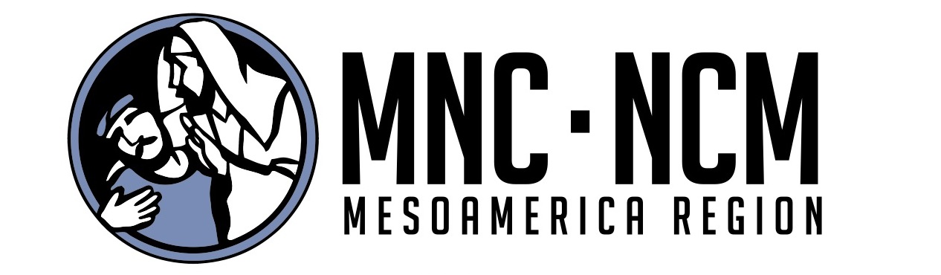

Guidelines for Safe Relief Distribution During Coronavirus (COVID-19) Response

One way to help vulnerable people who are isolated because of the coronavirus is the distribution of food and other essential items. However, it is important that great care is given to following protocol so that church members and community people are not at risk. This sheet incorporates best practices based on guidance from the World Health Organization. It is designed to help church volunteers and staff stay safe and to ensure that distributions carried out by churches do not increase the risk of COVID-19 transmission in the community. Note: there are other ways for churches to respond to Coronavirus aside from distributions, but these same guidelines will likely apply.

Two Key Principles:
- Follow your country’s national public health guidelines regarding the coronavirus. Most governments will follow the guidelines from the World Health Organization that can be found here: https://www.who.int/emergencies/diseases/novel-coronavirus-2019
- If you, a) are feeling sick or have any of the symptoms
OR
b) have been in contact with anyone who either has the symptoms or is feeling sick, or tested positive for COVID-19, do NOT participate in these efforts.

Food Items
- Wash hands thoroughly before packing any food items and ensure that all packaging used for food is clean. Remember to wash hands regularly, including after you take any breaks while packing.
- Only pack food items that need to be cooked—rice, pasta, potatoes, beans, lentils, oil, flour, etc. Cooking of food items will reduce risk of transmission. Do NOT pack fresh food items. Multi-vitamins are OK, but should be in original packages that are sealed, and it should be made clear to the recipient that these are neither a treatment nor preventative for the virus, but simply a health-boosting supplement.
- Leave all food packages at the gate or door of the household and do NOT enter the house or stay to socialize.
- Do not shake hands with anyone and maintain a minimum distance of 6 feet (about 2 meters) from people.
- Do not touch door handles, gate handles, and other commonly touched surfaces. If you do, wash your hands after. Wash your hands regularly during distributions.
- Remind recipients to wash their hands.

Non-Food Items
- Our recommendation is to only deliver non-food items that are in original packaging. This can include hygiene items like soaps, cleaning materials, sanitary pads, diapers, etc.
- Wash hands before assembling packages and ensure packaging used is clean. Wash hands after breaks while packing.
- Leave all packages at the gate or door of the household and do NOT enter the house or stay to socialize.
- Do not shake hands with anyone and maintain a minimum distance of 6 feet (about 2 meters) from people.
- Do not touch door handles, gate handles, and other commonly touched surfaces. If you do, wash your hands after. Wash your hands regularly during distributions.
- Remind recipients to wash their hands.

Volunteer Training
- Make sure that all volunteers understand the public health guidelines and the above guidelines from NCM before participating. If anyone is unwell or has any symptoms, they must NOT participate in the response. Volunteers that have fragile health themselves should also NOT participate in the response.
- If soap and water is not easily available when carrying out distributions, make sure volunteers have hand sanitizer (alcohol-based) so they can regularly clean their hands.
- For helpful posters/flyers from the World Health Organization: https://www.who.int/emergencies/diseases/novel-coronavirus-2019/advice-for-public
- For helpful Questions and Answers on the coronavirus:
https://www.who.int/news-room/q-a-detail/q-a-coronaviruses
General Reminders
- Avoid touching eyes, nose, and mouth.
- Practice respiratory hygiene — This means covering your mouth and nose with your bent elbow or tissue when you cough or sneeze. Then dispose of the used tissue immediately.
- Wash hands regularly — even if they don’t look dirty. Watch this video for how to wash your hands properly! https://www.youtube.com/watch?v=y7e8nM0JAz0
- Maintain distance from others — stay a minimum of 6 feet (about 2 meters) from people.

