LESSONS 2018

DISCIPLES OF THE BIBLE

A LIFE INVESTED IN:
PRAYER
RELATIONSHIPS
TEACHING
SERVING
(2 TIMOTHY 2:2)

Table of Contents
Introduction

1. Daniel teaches me to pray

2. Miriam teaches me to care for others

3. Moses teaches me to be patient

4. Samuel teaches me to serve

5. Josiah teaches me to be responsible

6. David teaches me to be brave

7. Jesus teaches me to be kind

8. A boy teaches me to share.

9. Timothy teaches me to study

10. Naaman’s servant girl teaches me to be a witness

INTRODUCTION

Through the praise of children and infants you have established a stronghold against your enemies, to silence the foe and the avenger.

Psalm 8:2

It is a great privilege to present this series of lessons: Disciples of the Bible. These lessons are based on the quadrennial theme for 2017-2021:

A life invested in prayer, relationships, teaching, and serving. (2 Timothy 2:2)

With the general objective: That children develop attitudes of appreciation for prayer, develop friendship and learn to serve.
Specific objective: That the children understand that we are special to God. To prepare those with disabilities of Down Syndrome; mental retardation, and Cerebral Palsy.
These lessons are for those with a mentality between 6 to 10 years; non-chronological (The person can be 20 years old and still think like a 5-year mind)
It is very important that a psychological evaluation be done, with the help of the SDMI council, but if that isn’t possible, the teacher should observe to decide on a basic mental age of the student.
There are two sides on a coin and when we have it in our hands we cannot remove one of the sides. In the same way if we want to help our children learn, we must remember that:
Emotions and intelligence are inseparable, so that when one is given, it must be accompanied by the other and vice versa.
If you want your children to learn, you must do everything with love: all presentations with love, anything you request must be with love, etc.. Without love you, won’t help them know God, because God is love. For what we can say.

GREATER FEELINGS - GREATER DEVELOPMENT

Prepared by: Sister Cecilia Gómez de Diaz.

Regional Director for Gift of Love Nazarene Ministries
Mesoamerica Region, Church of the Nazarene

(Ministry of spiritual attention to people with disabilities)
Email: dondeamor_nazarenos@hotmail.com
cecydediaz@hotmail.com

- Daniel Teaches Me to Pray

Text: “Pray always.” – 1 Thessalonians 5:17

Parts of the lesson | Methodology | Resources | Time
Greetings Welcome | Greet each student and give them a name badge. | Name Tags | 3 min.
Waiting area | Puzzles of hands to assemble, Figurines of people praying, telephones and computers. | Visuals and a toy telephone. | 5 min.
Opening Prayer | Get the students into small groups with one leader in each group to pray, or allow students to pray in each group, or pray as one large group. | Hands folded for prayer | 2 - 3 min.
Singing | Sing 2-3 songs, including, God Cares For Me |  | 5 min.
Activity | The teacher calls by phone or sends an email by toy computer and talks to God.  Allow each student to participate if time allows. | Telephone or toy computer | 3 - 5 min.
Introduction to the theme | Explain that prayer is the way we communicate with God to give thanks, praise him and ask for what we need. Continue developing the topic, sensitizing and applying the teaching. Tell the story of Daniel. | Picture of Daniel praying. | 5 min.
Craft | Some of the students might need a little help with coloring the handout of Daniel praying. If they don’t finish, they can take it home to finish there. | Colored pencils, crayons, the handout drawing | 10 min.
Farewell with the blessing of God. | Encourage your students to pray this week. End the class by praying for each of the students, and then give them a small snack. | Snack | 5 min.

Bible Story - Daniel 2

Introduction: Prayer is a Blessing; it is how we talk with God, to say thank you and to ask for His help with our health, with direction in our lives, and for the things we need, like food, clothes, a place to live, and safety.
Start by showing the picture of Daniel praying and tell the story:
Although Daniel was very young ,He prayed when he was in Babylon where he was a slave. There were always people watching him.
One day, the king had a very strange dream that made him worry a lot. He asked his advisors to tell him his dream, and then tell him what his dream meant. However, none of them of them could do that. So then he told them that they would be killed. Daniel heard about this and volunteered to give the King the answers he wanted. But first, Daniel explained that he needed to pray and talk to God, because God was the one who could answer the King’s questions. So Daniel and his friends prayed a long time for many hours, asking God to tell Daniel what the King had dreamed, as well as the meaning of the dream. God answered their prayers and told Daniel what the King had dreamed, and the meaning of the dream. Then he went and told the King about his dream and its meaning.
God wants us to talk to Him and tell Him our joys and the good things that happen to us, as well as to say thank you to him. He also wants us to tell him about the things that make us afraid, the things that make us sad, if we are worried or we feel alone, or about the things that are needed in our homes.
Give the worksheet to each student so that they can finish the picture and color it.
Tell them they can prayer out loud with our voice, or just pray our prayers with our thoughts. God can hear our thoughts.
We must try to pray every day like Daniel.
Read the text again (“Pray always.” – 1 Thessalonians 5:17) and repeat that “Prayer is talking to God as he teaches us.”
Talking to GOD is fun!!!

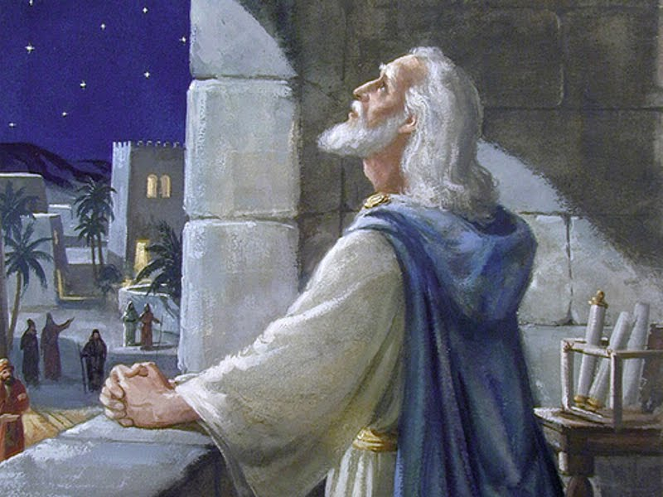

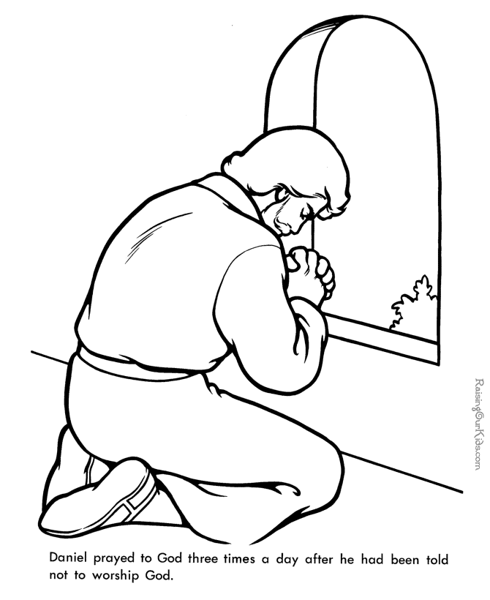

- Miriam Teaches Me To Care For Others

Text: “His sister stood at a distance to see what would happen to him.”

Exodus 2:4

Parts of the lesson | Methodology | Resources | Time
Greetings Welcome | Greet each student and give them a name badge. | Name Tags | 3 min.
Waiting area | The can play with toy tambourines; figurines of children, babies, a bassinet to sleep babies | Visuals, toy tambourines. | 5 min.
Opening prayer | Get the students into small groups with one leader in each group to pray, or allow students to pray in each group, or pray as one large group. | Praying hands of each student | 2-3 min.
Singing | Sing 2-3 happy songs and about the theme of Miriam, Moses, and caring for others. | Toy instruments | 5 min.
Activity: Get in order | Put the long strip of paper on the floor, and have all of the students make a straight line standing on the paper. When the leader gives the signal, they must rearrange themselves according to height, shortest to tallest.  (help them and support them) | A strip of paper 20 cm wide and long enough for all of your students to stand on at the same time. | 3-5 min.
Introduction to the theme | Explain that God has created us with a purpose and that we all have something to do for God. Continue developing the topic through the Bible Story and applying the teaching. | Picture of Miriam | 5 min.
Craft | Allow the students to color the pictures and then cut out and glue baby Moses into the River. | Colored pencils, crayons, scissors, glue, copies of the handout | 10 min.
Farewell with the blessing of God. | Encourage your students to help others this week. End the class by praying for each of the students, and then give them a small snack. | Snacks | 5 min.

Bible Story: Exodus 2:1-8

Show a picture of Miriam to the class. (It can be from a book or online, or you can color the handout and show that.)
Miriam was the sister of Aaron and Moses. She had an important purpose from God which was not easy to fulfill, but her courage helped her to be faithful to her God.
She was born as a Hebrew slave in Egypt. They were mistreated by the Egyptians.
Miriam was raised by a mother (Jochebed) whose main objective was to serve the God of Israel. Miriam was a child when she was called to serve her God.
As we all know the story, shortly before Moses was born, Pharaoh made a law that required that all newborn Israelite babes to be thrown into the Nile River and die. Pharaoh was concerned that there were too many Hebrews, and that they might try to rebel against him.
When Moses was born, his parents didn’t throw him in the river like the law said, but instead they hid him in their home for three months. Finally when they couldn’t hide him any longer, his mother put him in a basket and taken to the Nile River under the care of his sister Miriam. At that time, Pharaoh's daughter went to take a bath in the river. While bathing, she heard a baby crying, and they found Moses inside the basket. Miriam approached and said to the princess, "My mom can take care of that baby for you if you would like her to."
Miriam was able to get the princess to entrust the care of Moses to his own mother. Miriam took the responsibility to watch over her brother. She was brave and she talked to the princess to help her baby brother.
She was smart, making it possible for her own mother to take care of Moses. Thanks to Miriam, Moses’ life was saved.
But Miriam's story does not end there. She saw how God divided the Red Sea; the water became two walls and Miriam went to the other shore where she danced and sang, giving thanks to God.
God loves Miriam for serving others.
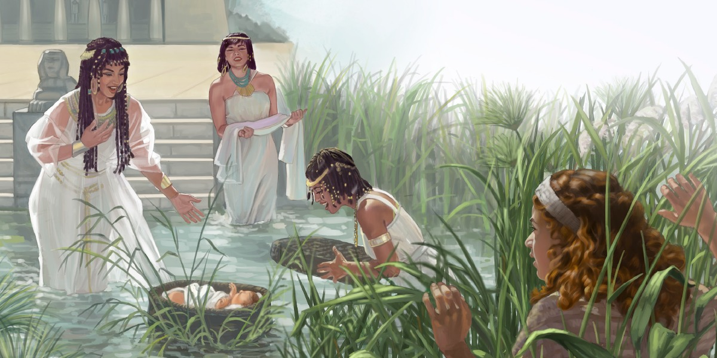
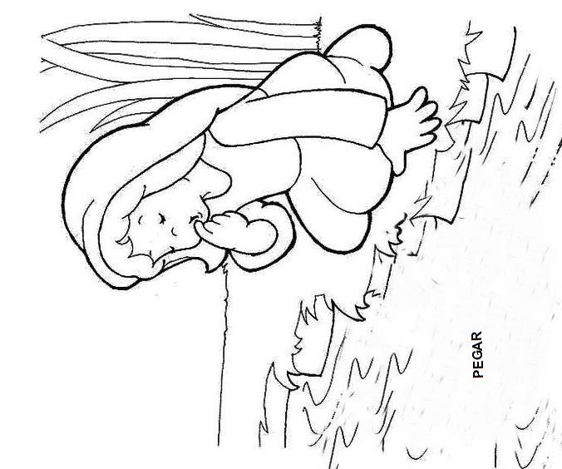

GLUE BABY MOSES HERE

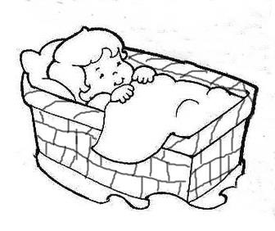
Color, cut out, and glue baby Moses in the river.

- Moses Teaches Me To Be Patient

Text: “I will never leave you or forsake you.”

Hebrews 13:5

Parts of the lesson | Methodology | Resources | Time
Greetings Welcome | Greet each student as they arrive. Ask about how their week was. Give them their name tag. | Name Tags | 3 min.
Waiting Area | The students can assemble puzzles of 5 or 6 pieces and then disassemble them and pass on to someone else. | One puzzle for each student | 5 min.
Opening Prayer | Get the students into small groups with one leader in each group to pray, or allow students to pray in each group, or pray as one large group. | Praying hands | 2-3 min
Songs | 2-3 happy songs, songs about patience, Moses, etc. | Clapping along with the songs. | 5 min.
Activity | Ask the children to close their eyes while you hide the basket in a visible place. They will open their eyes and look for the basket and can raise their hands and point to it. | Basket or box with a baby doll in it | 5-7 min.
Introduction  of the theme | Start by asking what is "Patience." After getting some answers from the students, clarify the definition. Continue developing the topic through the Bible Story and applying the teaching. | Picture of Baby Moses with Pharaoh’s daughter. | 5 min.
Craft | The guides can help the students color the pictures and then cut out the pictures and glue them if they need help. | Colored pencils, crayons, scissors, glue, copies of the handout | 10 min.
Farewell with the blessing of God. | Encourage your students to be patient this week. End the class by praying for each of the students, and then give them a small snack. | Snacks | 5 min.

Moses Teaches Me To Be Patient

Exodus 2:6-9

Why did baby Moses cry?

A) Because he was hungry
B) Because he was alone and wanted his mom
C) Because he felt the water

Even though he was a baby, Moses was able to wait in the arms of the princess until his mother arrived, even though maybe he wanted to eat, or maybe he got wet in the basket.
God made all people different, and we must be patient if they are faster or slower than us. If someone cares for us, we should also have patience and wait for our mom or dad or the person who takes care of us to do what they need to do or go somewhere where they cannot take us.
If you are patient, you will be more helpful to people, friends and teachers. You will have better friendships if you are patient with them. It is good to be patient when you’re waiting in lines or waiting for a puzzle or a toy.
God wants that when we make prayer requests we wait and accept what he decides for us.
Even if you are small or big, God wants us to be patient like the baby Moses was.

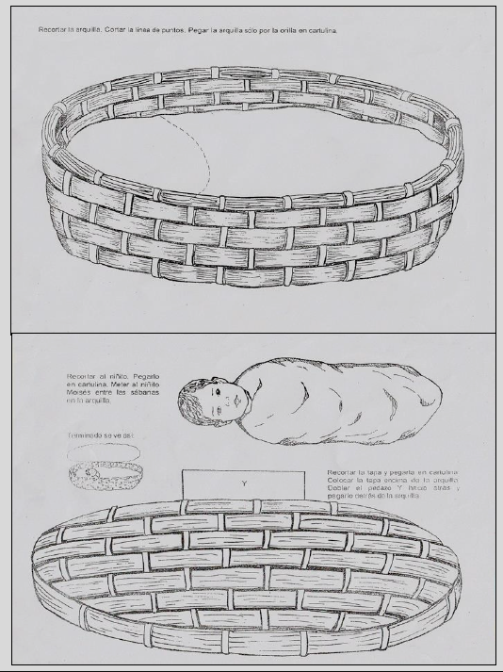
Cut out the lid and then fold down and glue the tab Y to the inside of the basket so the basket can be opened and closed.
It will look like this when finished.
Cut out baby Moses and glue him into the basket.
Cut out the basket.
- Samuel Teaches Me To Serve

Text: “Let us love one another.”
(1 John 4:7)

Parts of the lesson | Methodology | Resources | Time
Greetings Welcome | Greet each student as they arrive. Ask about how their week was. Give them their name tag. | Name Tags | 3 min.
Waiting area | “Your name” - Each student gets 2 tries to pick the card with their name out of the box. If they are successful, they get a prize like a sticker or something small. | A box with cards with the names of each student | 5 min.
Opening Prayer | Get the students into small groups with one leader in each group to pray, or allow students to pray in each group, or pray as one large group. | Hands folded in prayer | 2-3 min.
Singing | 3 happy songs or songs about serving others. Let the students play instruments along with the song. | instruments | 5 min.
Activity | Record the names of each of your students. Then play the recording, and when a student hears their name, they are to say, “I’m here.” | recorder | 5 -7 min.
Introduction to the theme | Show the picture of Samuel and his parents in the temple and tell the story with emotion. | Picture of Samuel and his parents in the temple. | 5 min.
Craft | The guides can help the students color the picture of Samuel if they need help. The students can finish their pictures at home if there isn’t enough time during class. | Colored pencils, crayons, copies of the handout of Samuel | 10 min.
Farewell with the blessing of God. | Encourage your students to serve others this week. End the class by praying for each of the students, and then give them a small snack. | Snacks | 5 min.

Samuel Teaches Us To Serve

1 Samuel 3:1-10

A little boy served God. His name was Samuel. (Show the picture of Samuel and his parents.) The man with the hat is the high priest of Israel, Eli. The adults with little Samuel are his father Elcana and his mother Ana.
Samuel was only four or five years old when his parents brought him to live with Eli and with the other priests. Why would Elkanah and Anna bring someone as young as Samuel to serve Jehovah in the tabernacle? Let's see.
Because his parents had taught Samuel so well, he was happy to be able to serve Jehovah in the tent of the Lord. Each year his parents came to worship in this special place, and to visit their little son. And every year Ana would bring a new outfit that she has made for Samuel.
The years went by, and Samuel continued to serve in the tabernacle of Jehovah, and it pleased God and the people.
Young Samuel did not let any of the bad things that happened in the tabernacle cause him to stop serving Jehovah. But for a long time, God had not spoken to anyone, because few people really loved him. When Samuel grew a little more, this happened:
Samuel was sleeping in the tabernacle when a voice woke him up. He answered, “Here I am.” And he got up and ran to Eli, and he said, “You called me, and here I am.”
But Eli answered, “I didn’t call you; Go back to bed.” So Samuel went back to bed. Then there was a second call, “Samuel!” So Samuel got up and went back to where Eli was. “You called me, and here I am,” he said. But Eli answered: “I didn’t call you, my son. Go back to bed.” So Samuel went back to bed.
“Samuel!” called the voice for the third time. So Samuel ran to Eli. “I'm here. This time you must have called me,” he said. Then Eli knew that it was God who called Samuel. He said to Samuel, “‘Lie down again, and if he calls, you must say, 'Speak, God, for your servant is listening.'"
That's exactly what Samuel said when God called him again. God spoke to Samuel that night, and many times afterwards. Samuel grew up, and became a great leader for Israel.

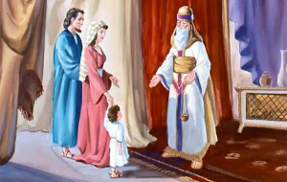

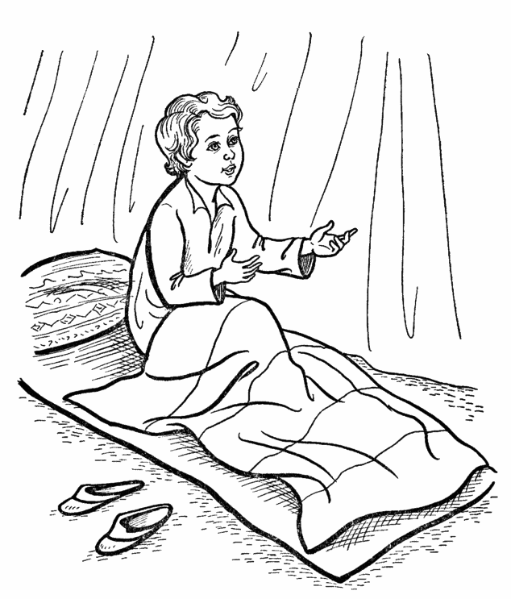

- Josiah Teaches Me To Be Responsible

Text: “Josiah was eight years old when he became king, and he reigned in Jerusalem thirty-one years. He did what was right in the eyes of the Lord.”
(2 Chronicles 34:1-2)

Parts of the lesson | Methodology | Resources | Time
Greetings Welcome | Greet each student as they arrive. Ask about how their week was. Give them their name tag. | Name Tags | 3 min.
Waiting Area | Provide small “scrolls” with short Bible Verses that the students can unroll, read and roll up again. | Paper and popsicle sticks | 5 min.
Opening Prayer | Get the students into small groups with one leader in each group to pray, or allow students to pray in each group, or pray as one large group. | Everyone folding their hands for prayer | 2-3  min.
Songs | 2-3 happy songs, songs about responsibility |  | 5 min.
Activity | “Lost book” – The students must find the Bible that you have “lost” somewhere. Encourage everyone to help look. | A Bible | 5-7 min.
Introduction to the theme | Show a crown and picture of King Josiah and tell the story giving the students opportunities to ask questions. | Crown, Picture of the child king Josiah | 5 min.
Craft | Have the students color the pictures, and cut out the picture of King Josiah and glue it in the place designated. The guides can help if the students need help. The students can finish their pictures at home if there isn’t enough time during class. | Colored pencils, crayons, scissors, glue, copies of handout | 10 min.
Farewell with the blessing of God. | Encourage your students to serve others this week. End the class by praying for each of the students, and then give them a small snack. | Snacks | 5 min.

Josiah Teaches Me To Be Responsible
2 Chronicles 34, 35

What would it be like if the president of your country was a child? Do you think that would be possible? No, because today nobody chooses a child to govern the country.
But the Bible says that there were times in the past when there were children who were rulers. When a king died, his oldest son would be the next king. Sometimes, the oldest son would still be young, but they would still be made king.
One such child king was Josiah.
A) Josiah obeyed God - When Josiah heard about the miracles and all the other wonderful things that God had done for his people Israel, things that we can read in the Bible, he felt a desire in his heart to serve God. The Bible tells us that Josiah obeyed God in everything, because he "followed the good example of his ancestor David."
One of God's commandments is that we do not make idols or images to worship. The Hebrew people had not obeyed God, and throughout the country there were altars and images of false gods. Josiah ordered the people to destroy all of the idols and altars to false gods.
B) The temple was in ruins - As people worshiped images and false gods, they had neglected the temple of God. The temple was a mess! So Josiah gave orders to have it repaired. While they were doing the repairs, the priest Hilkiah found the book of the Law (which was part of the Bible) which God had given through Moses.
“I found the book of the Law in the temple of God!” Hilkiah said to Shaphan, the king's secretary. Soon Josiah received the news. And his secretary read him the book. When the king heard the reading, he tore his clothes as a sign of sadness. That was a custom in those days.
“God must be furious with us!” said Josiah. We have not obeyed what is written here!”
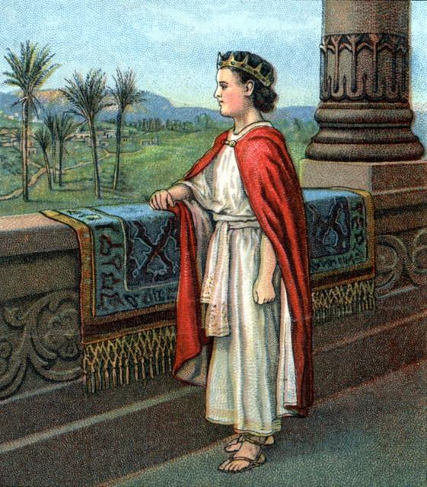
C) Josiah read the book of the law - Then, Josiah wanted everyone to hear the words of the book of the Law of God. He ordered that all of the leaders of Judah and Jerusalem were to gather in the temple with him. The whole nation responded, from the youngest to the oldest, and went to the temple. There, the king himself read them what the book of the Law of God said.
What else did Josiah do? He tried to always obey the commandments of God, and he commanded all of the people to do the same. From the smallest to the biggest, they promised to obey and fulfill the Word of God.
If you were king or queen, how would you rule?

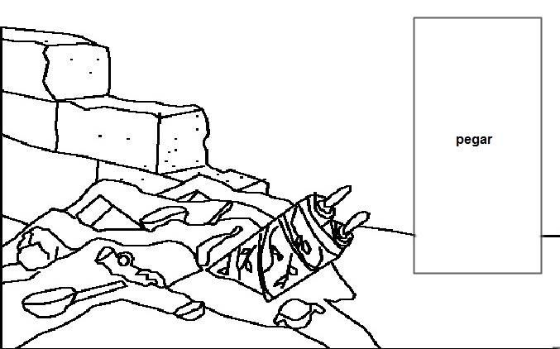
Glue King Josiah here

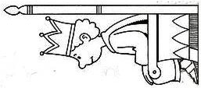
Color and cut out the picture of King Josiah and glue it in the space designated in the picture.

- David Teaches Me To Be Brave

Text: “Have I not commanded you? Be strong and courageous. Do not be afraid;
do not be discouraged, for the Lord your God will be with you wherever you go.”

(Joshua 1:9)

Parts of the lesson | Lesson Plan | Resources | Time
Greetings Welcome | Greet each student as they arrive. Ask about how their week was. Give them their name tag. | Name Tags | 3 min.
Waiting area | Have pictures on tables of shepherds, sheep, lions, bears, shepherd’s crooks, and slings for the students to color while they are waiting for the class to begin. | Pictures to color of shepherds, sheep, lions, bears, shepherd’s crooks, slings, colored pencils, crayons | 5 min.
Opening Prayer | Get the students into small groups with one leader in each group to pray, or allow students to pray in each group, or pray as one large group. | Everyone folding their hands for prayer | 2-3 min.
Songs | 2-3 happy songs, songs about David, bravery, etc. |  | 5 min.
Activity  “Caring for ourselves” | Pair the students up, and then connect each pair with a strip of paper between them. The object is to walk together without breaking the paper. The pair that arrives to the finish line first without breaking the paper are the winners. | 1 foot long strip of paper for every two students, tape | 5-7 min.
Introduction to the theme | Show the students the picture of David, and then ask the students to close their eyes, imagine a green field or meadow ... and then start telling the story. | Picture of David | 5 min.
Craft | Have the students color the picture. The guides can help if the students need help. The students can finish their pictures at home if there isn’t enough time during class. | Colored pencils, crayons, copies of handout of Samuel anointing David | 10 min.
Farewell with the blessing of God. | Encourage your students to be brave this week. End the class by praying for each of the students, and then give them a small snack. | Snacks | 5 min.

1 Samuel 16, 17

Hi, my name is David. As a child I was a quiet little shepherd boy who sang and played his harp to the sheep to keep them calm. I was very brave when I had to defend the sheep from the wild animals and had to chase them away.
I was also brave when my father Jesse sent for me and my seven older brothers, to introduce me to a priest named Samuel. I couldn’t believe it when Samuel told me that he was going to anoint me with oil by the order of God to someday be the King of Israel. It was a little scary, but later I felt happy because God’s Holy Spirit gave me peace.
Later, King Saul asked me to play my harp for him, and when I praised God, the King was happy and calm.
When the day came that I had to face the giant Goliath, the whole army of Israel was afraid. I chose to be brave and to face him with my little sling. I knew that with the power of God, I could be strong and beat anyone, just as God had helped me protect the sheep.
You also can be brave like I was!
When you begin to feel alone and afraid, remember that you have a very big and very strong God who wants to help you to be brave and bold. With God’s help and his protection, you have nothing to worry about.
.
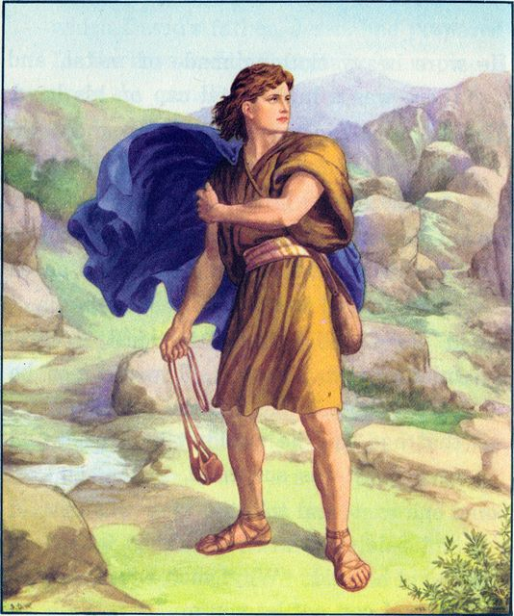

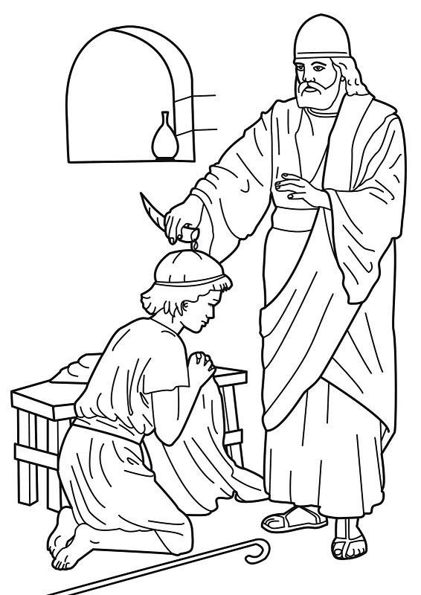

7. Jesus Teaches Me To Be Kind

Text: “Let your kindness be evident to all.”

(Philippians 4:5)

Parts of the lesson | Methodology | Resources | Time
Greetings Welcome | Greet each student as they arrive. Ask about how their week was. Give them their name tag. | Name Tags | 3 min.
Waiting area | Provide figurines for the children to play with - of Jesus, carpentry items like Jesus would have used, etc. | Figurines | 5 min.
Opening Prayer | Get the students into small groups with one leader in each group to pray, or allow students to pray in each group, or pray as one large group. | Hands folded in prayer | 2-3  min.
Activity  “Growing” | Put a ruler or measurements on the wall, and measure each student’s height. Students can help measure each other. After each student has been measured, say something nice to him/her. | Something to measure height | 5-7 min.
Introduction of the theme | Show the students the picture of young Jesus working with his father Joseph, and tell them the brief story. Allow them to ask questions. | A picture of Jesus as a boy working with his Father Joseph. | 5 min.
Craft | Have the students color the picture of Jesus in the carpentry shop with his father Joseph. The guides can help if the students need help. The students can finish their pictures at home if there isn’t enough time during class. | Colored pencils, crayons, copies of handout | 10 min.
Farewell with the blessing of God. | Encourage your students to be kind to others this week. End the class by praying for each of the students, and then give them a small snack. | Snacks | 5 min.

Jesus Teaches Me To Be Kind

Luke 2:40, 51

“And Jesus grew in wisdom and stature, and in favor with God and man.”

(Luke 2:52)

“Hi, my name is Jesus. When I was a small boy I liked to sing, play, read and draw, like most children. I also spent time talking with God, my heavenly father.”
“A lot of the time I spent learning with my father Joseph. He was a carpenter and he taught me how to make things with wood, like furniture, benches and other things. I was a good helper for him. I learned quickly and with care to finish everything I started. God likes us to dedicate time to others, a smile, a greeting, use the good words with all people: good morning- thank you very much- excuse me – I’m sorry, etc.”
Jesus really loves people, serving selflessly and giving His life for them. He expects his followers-especially the children who are part of His people-to be humble and meek like Him.

God loves kindness!

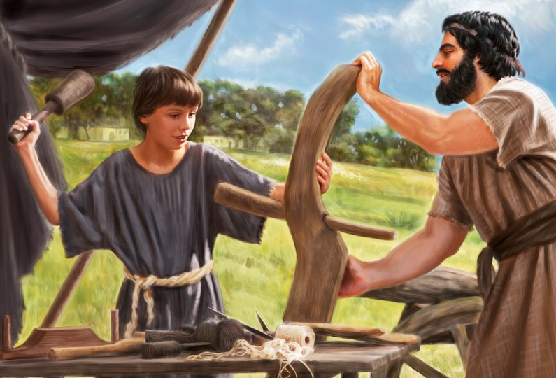

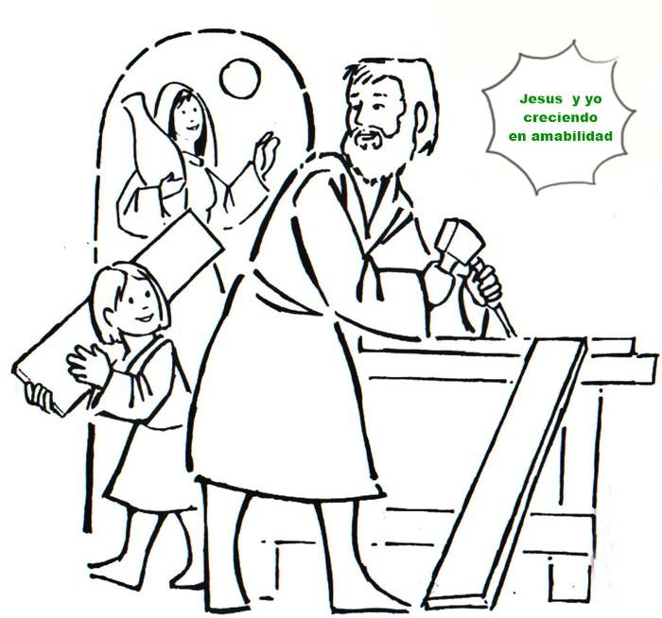
Jesus and I grow in kindness.

- A Boy Teaches Me To Share

Text: “It is more blessed to give than to receive.”

Acts 20:35

Parts of the lesson | Methodology | Resources | Time
Greetings Welcome | Greet each student as they arrive. Ask about how their week was. Give them their name tag. | Name Tags | 3 min.
Waiting area | Figures of children who are hungry, for the students to see and touch and begin thinking about people who are hungry.. | Photos and figures of hungry children | 5 min.
Opening Prayer | Get the students into small groups with one leader in each group to pray, or allow students to pray in each group, or pray as one large group. | Hands folded for prayer. | 2-3  min.
Singing | 2-3 songs that are upbeat |  | 5 min.
Activity | Have a small bowl or basket with small pieces of cookies. Put on it a sign that says, “For everyone” | Container, cookies | 5-7 min.
Introduction of the theme | Start telling the story, setting the scene of the large crowd that is hungry. Ask the students, “What will they do to get food? Do you have any ideas?” Some of the students may know the story already. After they have given their suggestions, continue with the story and show them the picture of the boy sharing his lunch. | A picture of the boy sharing his lunch. | 5 min.
Craft | Have the students color the picture of the boy sharing his lunch. The guides can help if the students need help. The students can finish their pictures at home if there isn’t enough time during class. | Colored pencils, crayons, copies of the handout | 10 min.
Farewell with the blessing of God. | Encourage your students to be share with others this week. End the class by praying for each of the students, and then give them a small snack. | Snacks | 5 min.

A Boy Teaches Me To Share

(John 6:1-15)
One day Jesus spoke to more than five thousand people, and when it was late, the people were hungry. But I wasn’t concerned. I'm a smart kid and I brought my lunch. Mom made me a lunch and put five loaves of bread and two roasted and very fat fish just for me.
But when I heard that all the people had nothing to eat and one of the disciples, Andrew asked me if I wanted to tell Jesus that I was the only one who had food, I told him yes, and they took me to Jesus. I decided to share my lunch with him. Jesus told me he would bless my food and we could share it. But I was about to have the biggest surprise ever. Although I gave Jesus my lunch that only had two fish and five loaves of bread, after Jesus prayed, there was lots of bread and fish. The disciples handed out bread and fish to all the people. There were even left-overs after everyone was done. It was great!
I had a little food, but Jesus multiplied it and made it enough for everyone! I learned that when I share what I have with others, Jesus blesses me with much more. I ate and was very satisfied, and I also saw that there was plenty of fish and lots of bread.
You also can share what you have with others. You can share with others by paying attention to their needs when you notice they don’t have enough. You can give them some of your toys, or clothes that are in good condition that you no longer use, or you can share your snacks with someone.
There are many ways to make others happy by sharing!!!

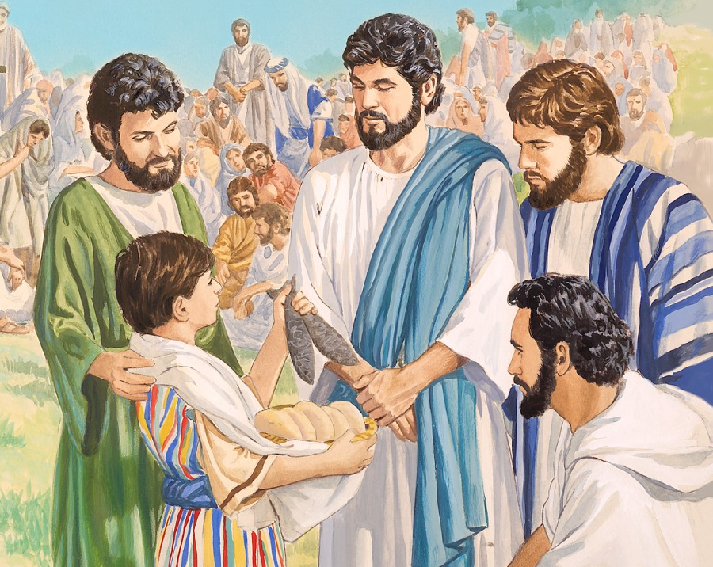

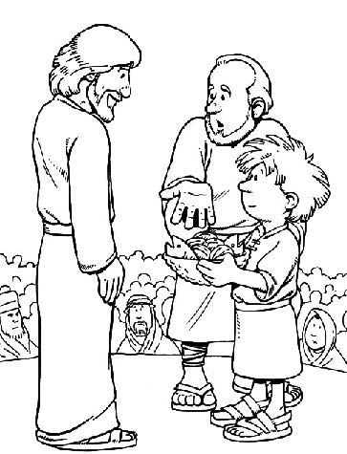

9. Timothy Teaches Me To Study

“If you love me, keep my commands.”

John 14:15

Parts of the lesson | Methodology | Resources | Time
Greetings Welcome | Greet each student as they arrive. Ask about how their week was. Give them their name tag. | Name Tags | 3 min.
Waiting area | “My reading photo” – Prepare a set in the corner of the room to take a photo of each student reading or studying. | Books, digital camera or phone camera | 5 min.
Opening Prayer | Get the students into small groups with one leader in each group to pray, or allow students to pray in each group, or pray as one large group. | Hands folded in prayer. | 2-3  min.
Singing | 2-3 active songs, songs about giving your best to God, etc. |  | 5 min.
Activity | “Shoes for me” Allow the students to try the kind of shoe they think they will wear someday when they grow up and have a job. | Try to have different kinds of shoes representing different professions: sandals, rubber boots, white shoes, dress shoes, etc. | 5-7 min.
Introduction of the theme | Show the students the photo of young Timothy studying, and then tell the story. | Picture of young Timothy studying with his grandmother and mom. | 5 min.
Craft | Have the students color the picture of Timothy studying about God with his grandmother. The guides can help if the students need help. The students can finish their pictures at home if there isn’t enough time during class. | Colored pencils, crayons, copies of the handout | 10 min.
Farewell with the blessing of God. | Encourage your students to study their school work and God’s Word. End the class by praying for each of the students, and then give them a small snack. | Snacks | 5 min.

Timothy Teaches Me To Study

1Timothy 4:6-16

I think that for many kids like me, it’s difficult to study at school, and sometimes I even think that what I’ll do when I grow up (be a traveler), I won’t need math or reading. But my teachers and our family tell me to "study and you’ll do well." Also, my mom and my grandmother tell me that I need to study the bible and pray. If I’ll do that, God will help me do what he wants me to do. Sometimes I get bored studying, but I always try to make an effort to learn all I need to know. Besides I like it when my grandmother tells me the bible stories and encourages me to read and study the Bible to grow in faith and in my love for God.
As my mom and grandmother trained me in good habits to study, I learned a lot about God's love and how he takes care of us.
And later, I became an assistant to the apostle Paul in his travels. Yes on his trips. God surprised me and let me be a traveler for a while. That gave me many opportunities to practice what I had learned at home and in the books I read. Also, I was privileged to meet many people and experience other cultures. So I continued to read and write the things I hear about Jesus in order to teach others.
You can also be a faithful helper by learning from your teachers and your parents.
And I want to give you a recommendation: when thoughts come to your mind that distract you at a bad time, whether you are reading a book or in classes at your school, you can learn to control them. Think that when you finish studying, then you can go out to have fun.

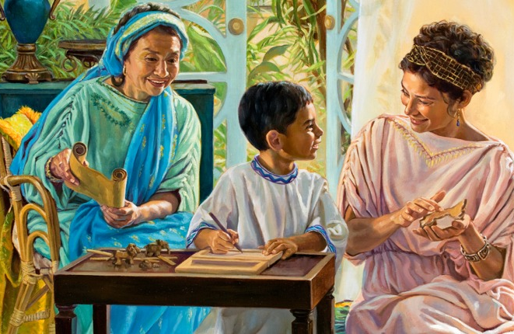

TIMOTEO ESTUDIANDO
Timothy studying about God with his Grandmother.

10. Naaman’s Servant Girl Teaches Me To Be A Witness

Text: “The one who is wise saves lives.”

Proverbs 11:30

Parts of the lesson | Methodology | Resources | Time
Greetings Welcome | Greet each student as they arrive. Ask about how their week was. Give them their name tag. | Name Tags | 3 min.
Waiting Area | Game with memory cards, they need to match up the same cards together. | Cards with Figures of Naaman, his servant girl, Elisha, etc. | 5 min.
Opening Prayer | Get the students into small groups with one leader in each group to pray, or allow students to pray in each group, or pray as one large group. | Everyone folding their hands for prayer | 2 - 3  min.
Singing | 2-3 Songs about being a witness for God. | Toy instruments | 5 min.
Introduction of the theme | Ask if anyone has had a pimple on their skin. Then show them picture of Naaman with leprosy. Then tell the story. | Picture of Naaman with leprosy | 5 min.
Craft | Have the students color the pictures, and cut out the pictures of Naaman and glue them to the front and back of a popsicle stick. The guides can help if the students need help. After they are done, they can tell the story of Naaman using their pictures on a stick. | Colored pencils, crayons, scissors, glue, popsicle sticks, copies of handout | 10 min.
Farewell with the blessing of God. | Encourage your students to share about God with others, just like Naaman’s servant girl shared with Naaman and his family. End the class by praying for each of the students, and then give them a small snack. | Snacks | 5 min.

Naaman’s Servant Girl Teaches Me To Be A Witness

2 Kings: 5:1- 4, 14

I’m a Jewish girl who was captured from Israel and taken to the country of Aram. There they took me to a house to help with the family chores of a man named Naaman. Naaman was a great general in the army, but he had a terrible disease called leprosy.
His wife prepared many medicines to alleviate her husband’s pain, but the poor man was very sad and worried about being sick. So even though I was afraid they would be angry with me, I asked permission from my mistress to talk to her husband. I told him about God and how God was so powerful that He could heal him of the leprosy.
I suggested that my master go see the prophet Elisha. Elisha could talk to God and ask God to help him. After listening to me, Naaman said he would go talk with the prophet just as I had suggested.
Elisha, the prophet of God, told Naaman to bathe seven times in the Jordan River, and when he did, he was cured.
I was very happy because I witnessed to Naaman and his family about the God of Israel and telling them how great and wonderful He is. They were very grateful and accepted the God of Israel as part of their lives.
Maybe you have friends in the church with whom you sing and read the Bible, but there are also many people and children who do not know God. You can learn to share your faith in Jesus, and speak to them about God so they can be happy and come to know Him.
And you will witness the wonderful things and miracles that God will do with your family and friends and others.
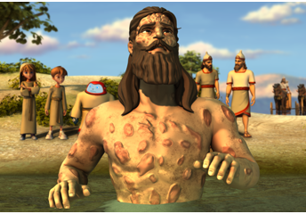

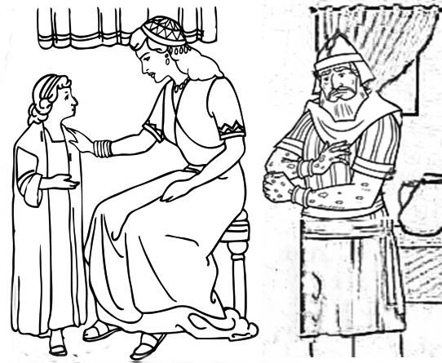

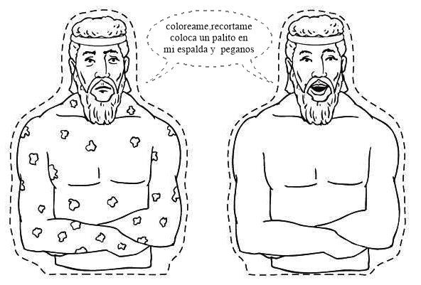
Color me, cut me out, and then glue me front and back to a stick.

